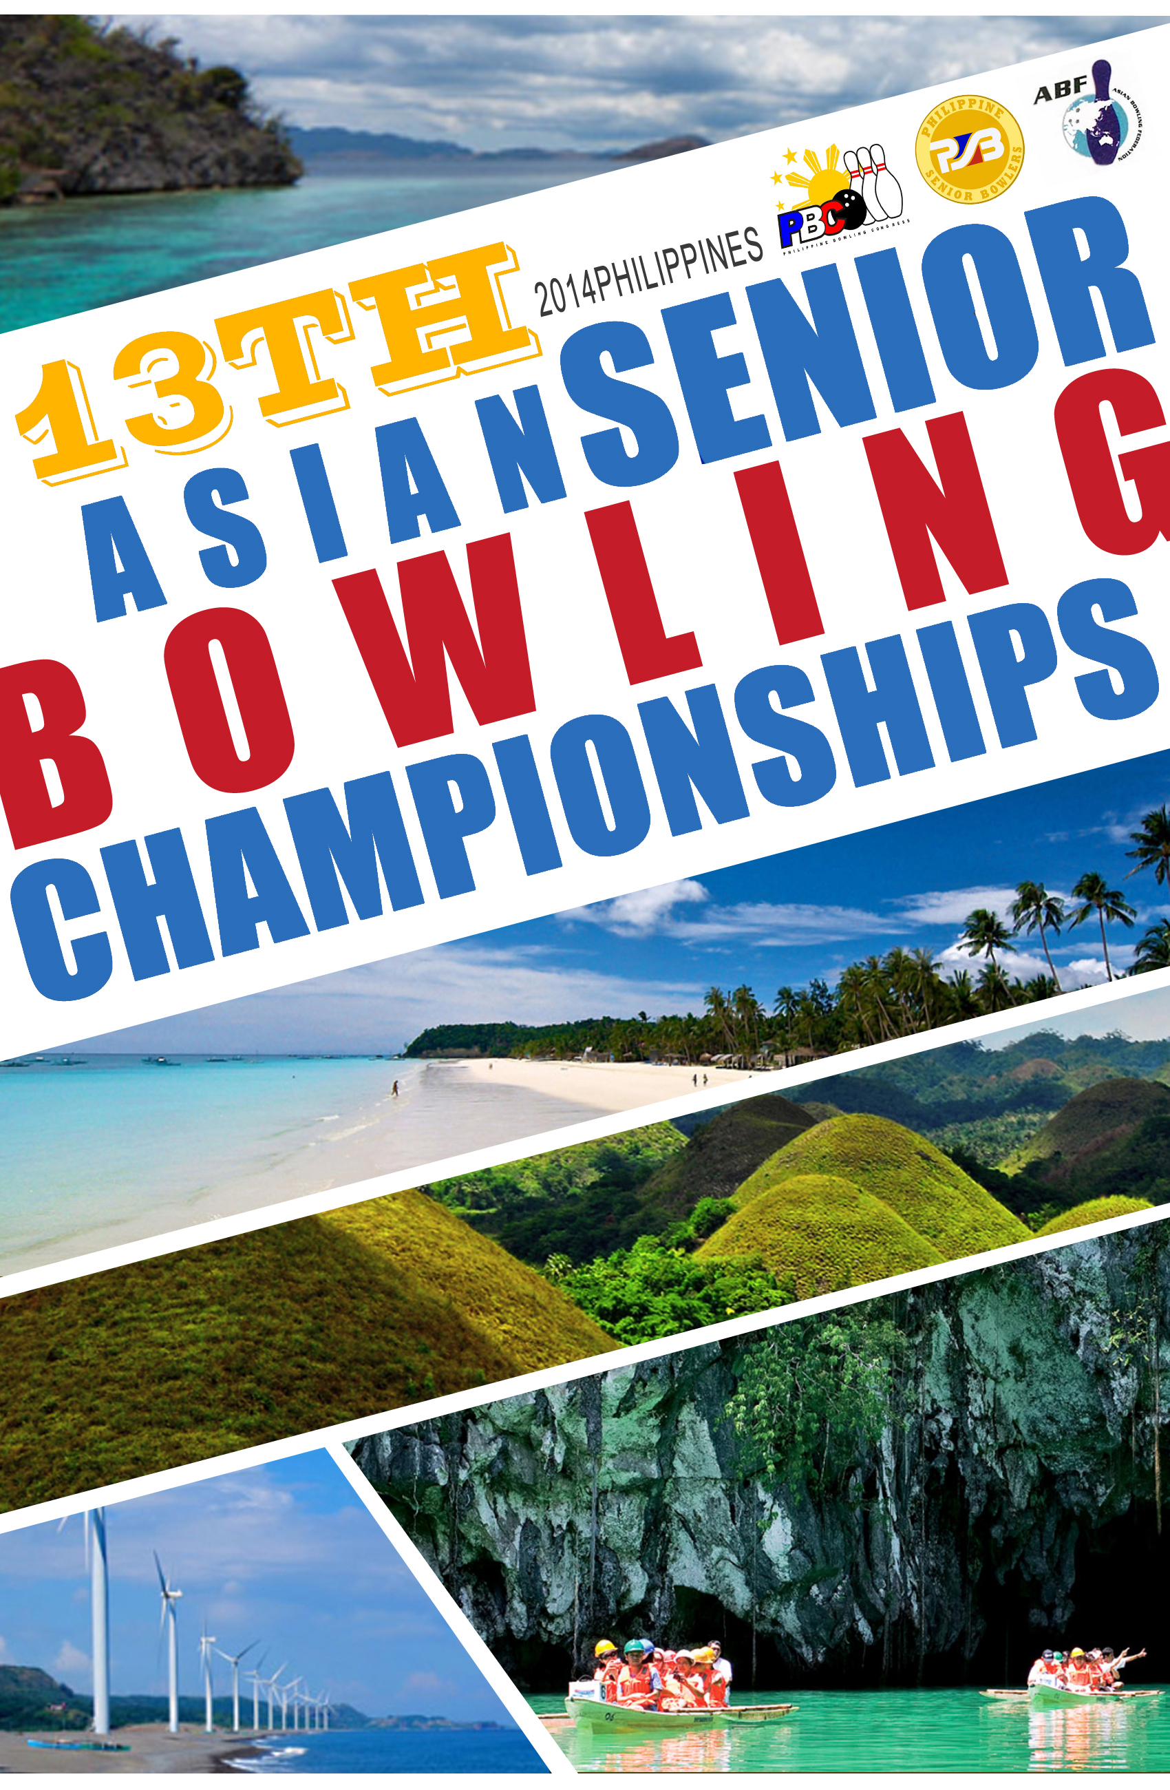

A. WELCOME

The Philippine Senior Bowlers is greatly elated and honored to host the 13th Asian Seniors Tenpin Bowling Championships.

The 13th Asian Seniors Bowling Championships will be held from November 25 to December 3, 2014 at AMF_Puyat Coronado Lanes - Starmall, EDSA cor Shaw Blvd., Mandaluyong City for members of the Asian Seniors Bowling Federation. This tournament is sanctioned by the ABF.

Philippine Senior Bowlers (PSB)

Contact Information : Steve E. Robles
President
#1 Cheza cor Gertrudes Sts., FEU Village
Mambugan, Antipolo City
Phone : +632 6813194-95 / +6326467624
Cell phone : +639175338109
Fax : +632 6813193
Email : steveerobles@me.com
Web : www.PhilippineSeniorBowlers.com

The official email for the 13th Asian Seniors Bowling Championships will be steveerobles@me.com

B. BOWLING CENTER INFORMATION

AMF-Puyat Coronado Lanes
Starmall, EDSA cor Shaw Blvd., Mandaluyong City
- Number of Lanes : 38 lanes
- Lane Surface & Approaches : Synthetic/wood
- Pin Decks : Synthetic
- Pin Setters : 8270
- Pins : Quibica AMF
- Scoring System : XL Scoring
- Oiling Machine : Silver Bullet Magnum
- Oil : Reactor
- Cleaner : Formula ACC

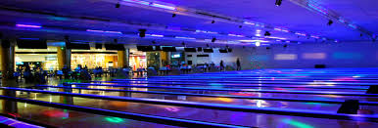

- OFFICIAL HOTEL

The official hotel for this championship is The Linden Suites rated five (5) star on San Miguel Avenue, Ortigas Center. The Linden Suites is within walking distance to financial, shopping and dining hubs in the area.

Inclusions:

- Buffet breakfast based on registered guest
- Internet access based on registered guest

+++++A lot of amenities

The following are the rate for room occupancy per night inclusive of taxes: Alloted Rooms

De Luxe Room (with kitchen) 2 Pax US$165 25
One Bedroom Suite (with living, kitchen
Dining) 2 Pax US$175 50
Two Bedroom Suit (with living, kitchen
Dining) 4 Pax US$255 10

Extra per person price: US$60per person/night
With buffet breakfast
Complimentary use of health club, swimming pool and gym.

Maximum room occupancy: De Luxe Room 3
One Bed Room Suite 3
Two Bed Room Suite 5

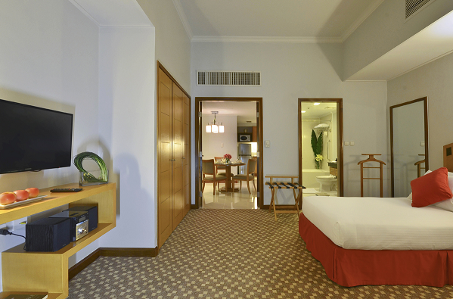
De Luxe Room
…with Kitchen

One Bedroom Suite
…with Living Room, kitchen and dining area
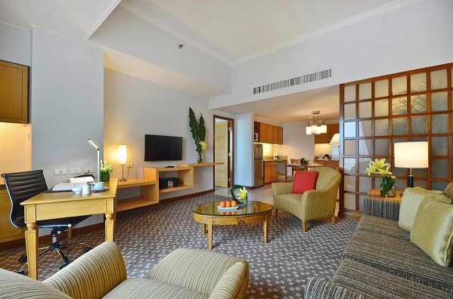

One Bedroom Suite
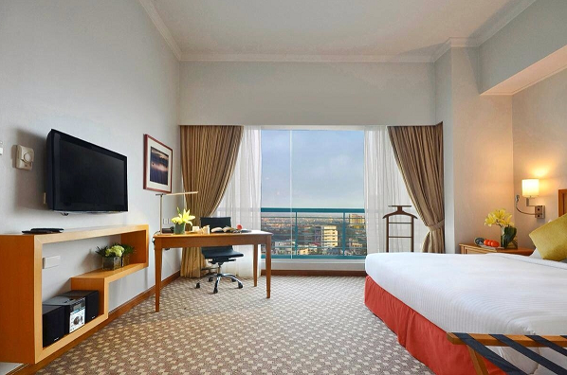
…Bedroom

Two Bedroom Suite
…with living room, dining and kitchen area
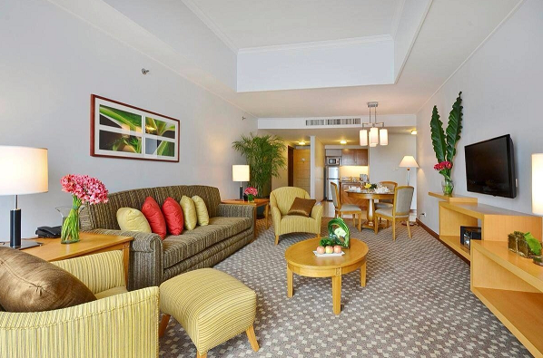

Two bedroom suite
…bedroom
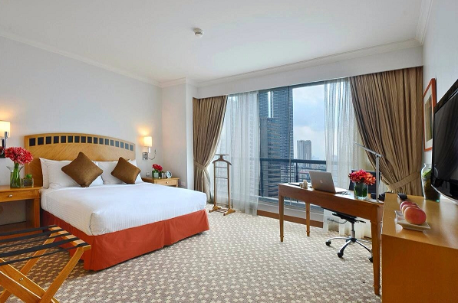

Deadline for booking – The deadline for reservations for the 13th Asian Seniors Bowling Championship is 31st August 2014. All bookings must be made by completing Forms B & C. Payment for accommodation must be received by 31st August to secure rooms. Special room rates will not be available for reservations made directly to the hotel and no shuttle service from/to airport will be provided if Federations stay in other hotel. Likewise those staying in other hotels will be required to pay US$200/person. Payments shall be made directly to PSB via bank transfer.
D. FACILITIES AND SERVICES

Entry Fee
The entry fee for each person (including players, coaches, managers, head of delegations and other officials connected to each team) participating in the Championship is US$200 as approved by the ASBC. The supporter’s fee for all non-bowlers(i.e. supporters, spouses, and children) will be US$150. This entrance fee will cover bus service, entry into the bowling lane during the competition, Welcome Reception in the Opening Ceremony and Victory Banquet. Please note that the entry form (Form A) must be completed and submitted to PSB by 30th June 2014.

All fees must be prepaid. Federations will receive an invoice after having submitted their ENTRY FORMS and are kindly requested to wire transfer the entry fees on or before 30th September 2014 the following account:

Bank Name: PHILIPPINE NATIONAL BANK
Bank Address: MATALINO QUEZON CITY
Account Number: 1902-00170-7
Account Name: STEM EXPORTS PHILS., INC.
SWIFT CODE: PNBMPHMM
Details of Payment: Please place your Federation’s name as reference

Press Facilities

The Philippine Senior Bowlers will offer facilities for accredited press during the Championship.

Bus Services

Bus service will be provided from the Airport to the official hotel and return on a fixed schedule for VIPs, participants and officials. For non-officials (i.e. supporters, spouses and children), bus transfers will be available to them provided they pay an “Entrance Fee”. As the host hotel and bowling center are on the same premises no transportation during the tournament is required.

Result Services

At the end of each squad results will be available in print for team managers and coaches.
At the same time, scores will be directly uploaded to the official Championship website.

Opening Ceremony and Welcome Reception

This event will be held at AMF –Puyat Coronado Lanes, Starmall on Wednesday 26th of November 2014 commencing at 6pm. All teams will be notified accordingly.

Bulletins and Information

From now on until the Championship commences, regular bulletins will be sent out to all bowling Federations as well as being featured on the official website.

Victory Banquet

The Banquet will be held on Tuesday, 02 December 2014 at 7pm at The Peak-Lancaster Hotel. Entry to the Victory Banquet is free to accredited players, officials and supporters. Additional tickets to the Banquet will be available upon payment of US$50.

National Anthems and Flags

All participating Federations are reminded to bring along 3 national flags (1 meter x 2 meters) and 1 CD of their national anthem.

Photographs

When submitting details of participants, officials and supporters, please send separately via email digital photographs of participants to facilitate us in the preparation of your accreditation tags in advance so they can be handed to you during the teams managers meeting. Failure to submit digital photographs will result
in the delay of accreditation tags being ready when you arrive.
Deadline for Submissions

Form Title | Form Code | Deadline
Entry Form | Form A | 30th June 2014
Hotel Form | Form B | 31st August 2014
Room List with Names | Form C | 30th September 2014
Arrival and Departure | Form D | 30th September 2014
Names in Delegation | Form E | 30th September 2014
Supporters | Form F | 30th September 2014
Bowler Information | Form G | 3oth September 2014
Ball Registration | Form H | Required at official Ball  Registration

E. TRAVELLING TO PHILIPPINES

Nationals from the vast majority of countries, including all ASEAN countries, can enter the
Philippines without a visa for a period of not exceeding 30 days, as long as they have a return or
onward ticket, as long as passports valid for at least 6 months beyond the period of stay.

F. SCHEDULE OF EVENTS

DATE TIME EVENTS

Day 1
Tuesday 25 November 2014 0900-1700 Arrival of Delegates/Ball Registration
1400-1600 A.S.B.C Executive Committee Meeting
1600-1800 A.S.B.C. General Assembly Meeting
1800-1930 Team Manager’s Meeting
Day 2
Wednesday 26 November 2014 0900-1700 Ball Registration (continued if required)
0730-0830 Lane Maintenance
0900-1030 Official Practice Squad 1
1030-1130 Lane Maintenance
1130-1300 Official Practice Squad 2
1300-1400 Lane Maintenance
1400-1530 Official Practice Squad 3
1800-1900 Opening Ceremony
1900-2000 Welcome Reception
Day 3
Thursday 27 November 2014 0730-0830 Lane Maintenance
0830-1200 Singles Squad 1
1200-1300 Lane Maintenance
1300-1630 Singles Squad 2
1630-1730 Lane Maintenance
1730-2100 Singles Squad 3
2100 Awards Ceremony – Singles Event
Day 4
Friday 28 November 2014 0730-0830 Lane Maintenance
0830-1200 Doubles Squad 1
1200-1300 Lane Maintenance
1300-1630 Doubles Squad 2
1630-1730 Lane Maintenance
1730-2100 Doubles Squad 3
2100 Awards Ceremony –Doubles Event
Day 5
Saturday 29 November 2014 0730-0830 Lane Maintenance
0900-1230 Team of Four – Block 1
1230-1330 Lane Maintenance
1330-1700 Team of Four – Block 2
Day 6
Sunday 30 November 2014 0730-0830 Lane Maintenance
0900-1230 Team of Four – Block 1 (continuation)
1230-1330 Lane Maintenance
1330-1700 Team of Four – Block 2 (continuation)
1700 Awards Ceremony – Team Event
Day 7
Monday 01 December 2014 0730-0830 Lane Maintenance
0900-1130 Masters Final – First Block Senior
1130-1230 Lane Maintenance
1230-1500 Masters Final - First Block Grand Senior
Day 8
Tuesday 02 December 2014 0730-0830 Lane Maintenance
0900-1130 Masters Final – 2nd Block Senior
1130-1230 Lane Maintenance
1230-1500 Masters Final – 2nd Block Grand Seniors
1500-1530 Awards Ceremony – Masters Event

1900 - Victory Banquet/Awards Overall Champion
Recognitions/Turnover Ceremonies/
Fellowship/and more Fellowship
Day 9
Wednesday 03 December 2014 Whole Day Departure of Delegates

G. RULES AND REGULATIONS

1. Date
November 25 - December 3, 2014

- Venue
AMF-Puyat Coronado Lanes - Starmall

- Divisions and Brackets
Men’s and Women’s Division
Senior Bracket 50-59 years old
Grand Senior Bracket 60 years old and above

- Events
Consists of the following events for the four brackets (Senior and Grand Senior Brackets for men and Women)
- Singles
- Doubles
- Four Player Teams
- All Events
- Masters
Note: In case there are less than 5 teams/bowlers entered for an event of a bracket, the event will not be conducted in the bracket.

- Competition Schedule (7)
Refer to the attached schedule

- Eligibility
6.1 Only athletes representing a member federation of Asian Senior Bowling Council are eligible to compete in the 13th Asian Senior Bowling Championships. Bowlers must be fifty (50) years old or above for Senior Bracket, sixty (60) years old or above for Grand Senior Bracket as of the end of the year 2014.

6.2 The athletes who take part in the 13th Asian Senior Bowling Championships shall meet the criteria stipulated in the WTBA Constitution and Rules.

6.3 Each member Federation of the Asian Seniors Bowling Council may enter the maximum of four (4) Men’s teams and four (4) Women’s teams for Senior and Grand Senior Brackets.

6.4 In case a four (4) player’s team or a doubles team from the same division consists of the bowlers from both Senior and Grand Senior Brackets, the team has to be registered in the Senior Bracket.

7. Entries
7.1 Entry Form
The deadline to submit the entry forms:
- Form A - 30th June 2014
- Form B - 31st August 2014
- Form C,D,E,F & G - 30th September 2014
- Form H - required at Official Ball Registration Day
- Passport size Photos - 30th September 2014 (via email)

7.2 Entry Fee
US$200 per bowler and official and US$150 per supporter (fees for games, transportation from the airport to the center, return to the airport, welcome reception, victory banquet, etc.)

8. Competition Methods
The 13th Asian Senior Bowling Championships will be conducted in accordance with the latest WTBA Rules and Regulations. In case of translation-related disagreement over the rules, the English text shall take precedence. Any unforeseen incident not addressed by the rules shall be resolved as follows:

General Issues: Resolve in accordance with the Asian Senior Bowling Council Rules and Regulations.

Technical Issues: Resolve in accordance with the spirit of WTBA Rules and Regulations.

8.1 Tournament Format

8.1.1 Style of Play
Each game shall be bowled on a pair of lanes. Teams and/or individuals shall successively and in regular order bowl one frame on one lane, and on the next frame
alternate and use the adjoining lane until five frames are bowled on each lane of the pair,
completing the game.

When there is a question concerning which of the two bowlers shall bowl first, it is incumbent upon the bowler on the right to do so.

8.1.2 Competition Procedure

8.1.2.1 Singles
Open to all members of each squad. 6 games in one block across twelve (12) lanes with, when feasible, two persons from the same federation scheduled per lane. Each game shall be played on a different pair of lanes. Players from a given federation shall be scheduled on at least two different squads if required.

8.1.2.2 Doubles
6 Games in one block shall be conducted across 12 lanes. Each game shall be played on a different pair of lanes. Two teams from each federation, one to be scheduled per lane. The teams of the same federation shall be scheduled on different squads if feasible. Change of player or order of bowling is not permitted at any time during the Doubles Event.

8.1.2.3 Four Players Team
6 games in two three-game blocks would be conducted in two days. Both blocks shall be bowled across twelve (12) lanes. One team scheduled per lane with each game of block bowled on a different pair of lanes. Line-up changes are not permitted during a block.

8.1.2.4 Masters Finals
Master Finals shall be round robin competition between the top 16 players based on their 18 qualifying games. A maximum of 4 players from each country will be eligible to qualify for the finals. All qualifying pinfalls will be dropped. One game matches will be played. The final match will be played as a position round, making a total of 16 games. The determination of champion is based on the total pinfalls (including bonus points) of 16 games.

These 16 games shall be bowled over two days, 8 games on the first day and 8 games on the second day according to a pre-arranged schedule.

Position number for the pre-arranged schedule shall be decided by draw. However, the Technical Committee will select position numbers for players from the same federation to ensure such players will compete against each other within the first 8 games, where possible.

Standings shall be based on total pinfalls from each of the matches together with a bonus of ten (10) for each match won, including the position round. Each player shall receive a bonus of five (5) for a tie.

- Any vacancies that may exist at the start of Master Finals shall be filled by the non-qualifiers available at the time and in order of finish in the qualifying competition. Ties between two or more players shall be decided by draw.

- Any semi-finalist who has not registered for the first eight (8)-game block prior to the time specified shall be replaced as described in (a) above.

9. Tournament Rules

9.1 Bowling Ball Inspection/Registration
a. Each player will be permitted to register a maximum of six (6) bowling balls during the tournament.
b. Immediately following the official practice (latest one hour after the last practice session) registration shall be made of the bowling balls to be used during the championship events.
c. Addition of two (2) bowling balls to the player’s ball list shall be allowed [up to the maximum of (6) six] throughout the tournament provided they are on the USBC approved list.
d. In addition to the foregoing, a maximum of one ball previously registered maybe re-moved from play during the Championships, and replaced by another ball not previously registered, upon notice to the Technical Delegate. Once this exchange process occurs the ball removed may not be returned to play.
e. Addition to a player’s bowling ball list shall be made no later than one (1) hour prior to the start of the squad where the additional bowling balls will be used.
f. In very special circumstances the Tournament Technical Committee may allow a replacement of a registered bowling ball.

Each day the events random inspection of the bowling balls may be performed. The Tournament Technical Committee shall decide on the number of balls and the players, which shall be randomly selected. The inspection shall be limited to a visual inspection of the serial number of the balls and the size and number of balance holes (refer to WTBA rule 11.14.3)

The penalties for violation of the rule above for a serial number and/or a number of balance holes violation:

- Daily random inspection, zero score for the event in which the failed inspection was performed.
- Medalists, zero score for the event.
- Masters Finals, disqualification and all scores null and void.
If a ball is in violation regarding the size of the balance hole, the ball shall be removed from play and cannot be used again until the balance hole complies. No additional balls may be added to the bowling ball list.

A maximum of five (5) gripping holes are allowed in a bowling ball. The player must be able to reach each set of gripping holes (not all for simultaneously) while using the thumb hole. Any hole, which cannot be reached, is considered a balance hole. The ball must be balanced twice when on set of finger holes are for fingertip and the other set for conventional grip.

When delivering the ball the player must have his/her thumb in or over the thumb hole. It may not be 180 degrees away from the hole.

9.2. Substitution
A player who has already started in an event shall not be replaced.

In case of the injured player having to leave the game, the remaining players on the team shall continue their games for all events purposes.

9.3 Interrupted Game
The Tournament Director may authorize the completion of a game and/or series on another pair of lanes when equipment failure on the starting lanes would delay the normal progress of the series. An interrupted game and/or series that cannot be completed on the same day must be resumed from the point of interruption on the next day.

9.4 Bowling on the Wrong Lane
A ball shall be declared dead and the player or players required re-bowling on the correct lane if no more than a total of 4 individual frames have been bowled on a pair of lanes by the players for Singles, Doubles, Trios and Team.

If more than four individual frames have been bowled on the wrong lane, that game will be completed without adjustment. Any succeeding game must be started on the correctly scheduled lane.

9.5 Tie-Break Procedures

9.5.1 The player or team with the highest score in each event shall be the winner. When equal scores (ties) are registered for any of the first three (3) places in the Four Player Teams, Doubles, Singles Events, co-champions or co-winners shall be declared. That is: in case of a tie for the 1st position, for example, the individuals or teams involved shall be declared a gold medalists, and 2nd and 3rd positions shall be filled from the next higher scores.

9.5.2 When a tie occurs for 16th place in the All-Events total, a one game roll-off shall be held. If a tie still exists a 9th and 10th frame shall be repeated until the tie is broken.

9.5.3 In case of a tie in the Master Final before the position round (after 15 games) between places 2-3,4-5,6-7 and so on, the player with the higher position is the one who in the round robin has:
a. The higher total scratch pinfall.
b. Won their match.
c. Won more matches.
d. The least difference between highest and lowest game.
e. The higher game.

9.5.4 When a tie occurs after the position round for first or third place, a one game roll off shall be held. If a tie still exist a 9th and 10th frame shall be repeated until the tie is broken.

9.6 Slow Bowling/Lane Courtesy
9.6.1 Players shall be ready to bowl when it is their turn and shall not delay the start of their approach or delivery when the pairs immediately adjacent to them on both the right and left are clear (one (1) pair lane courtesy.

9.6.2 Competitors must observe one (1) pair lane courtesy at all times. Competitors on the same pair may not bowl consecutive deliveries without allowing one competitor from the pair to the right and (1) one competitor from the pair to the left have made a delivery, unless those competitors are not ready to bowl or they gave way.

9.6.3 If a player does not observe the procedures outlined in 8.2.5.1 and 8.2.5.2 above, it may be construed as slow bowling. A player failing to observe these procedures shall be warned by an authorized tournament official as follows:

- A white card for the first offence (no penalty)
- A yellow card for the second offence (no penalty)
- A red card for the third and each succeeding offence in any block of games [six (6) games for singles and doubles, three (3) games for team and all games of match play in a day]. The penalty shall be zero pin fall for the frame.

For interpretation of the enforcement of this rule, the Referees/Tournament Officials shall specifically monitor any player or team that gets more than four (4) frames behind the leader in a singles, doubles or masters event; or more than two frames behind in trios or team, not counting the end pair of lanes. In Baker format competition the same rule applies as for the singles event.

Whenever there is question concerning the enforcement of this rule, or lack thereof, in the Masters Grand Finals, the ASBC President or his designee, notwithstanding the reference to the Referees/Tournament Officials, shall make the final decision.

9.7 Code Numbers and Lane Assignments
Code numbers shall be allocated by the Tournament Director and used to schedule lane assignments for each federation.

9.8 Line-up
All Line-up shall be submitted to the Tournament Office one day prior to the day of the event.

9.9 Handicap System
9.9.1 Handicap will be allotted during the championship on the basis of age and only after the age of 65 is obtained during the year of the championship.
9.9.2 Bowlers 64 years of age and below will not be given handicap and will compete on a scratch basis. Bowlers between the ages of 65 or who will turn 65 during the year of the championship until the age of 69 will be awarded five (5) pins of handicap per game. Bowlers between the ages of 70 or who will turn 70 during the year of the tournament and 74 shall receive ten (10) pins of handicap per game. Bowlers between the ages of 75 or who will turn 75 during the year of the championship until the age of 79 shall receive fifteen (15) pins of handicap per game, with additional five (5) pins of handicap being awarded thereafter to bowlers over 80 years in block of five (5) years.

9.9.3 Grand Senior Bowlers competing in the Senior Division will not be given handicap when bowling with the Senior Division for doubles or team event. However, handicap, based on age as described in 8.2.8.2, will be added for their All-Events standings.

9.9.4 If there is a total of four representatives and two are bowlers eligible for the Grand Senior while the other two members are eligible for the Senior Division, they shall be separated into two divisions during the doubles event by age category in order for the handicap to apply for the older aged bracket.

10. Uniform
All players shall wear a standard uniform approved by their federation. Individual variations are not permitted. The uniforms and advertising shall be in accordance with stipulations of WTBA Rules.

11. Equipment
Asian Senior Bowling Council will use equipment meeting FIQ-WTBA approved standards.

12. Competition Management

12.1 Responsibility for management of the competition will be assumed, under the guidance of the WTBA, ABF and ASBC, by an organization of competition officials belonging to and appointed by the host federation (Philippine Senior Bowlers).

12.2 Officials

12.2.1 Tournament Director
The host organization shall select a Director for the Tournament. He and his designated representatives shall supervise and direct the tournament. This shall include responsibility to the Technical Committee, Delegates of the Day, compliance with the WTBA Rules and Regulations and other WTBA directives.

12.2.2 Technical Committee
The Technical Committee shall consist of the Tournament Director, the Technical Delegate and Technical Committee Member. The President of the A.S.B.C. shall appoint all members of the Technical Committee except the Tournament Director who is appointed by the host federation.

The Technical Committee shall advise and counsel the host Tournament Committee and the Tournament Director regarding lane conditioning procedures and techniques on a daily basis during competition as well as prior to its start, from a date agreed in advance between the Technical Delegate and Organizing Committee. Should there be disagreement between the host Organizing
Committee and the Technical Delegate, the decision of the Technical Committee
shall be final.

12.2.3 Jury of Appeal
The President of the ASBC shall appoint a (3) three-member Jury of Appeal for the Championships and three (3) different federations must be represented on this body. It shall be empowered to cite before it all papers and persons involved in any appeal at a regularly scheduled meeting. Alternatively, if deemed appropriate, the Jury of Appeal may decide an issue by mail vote after all materials involved in the matter has been studied by each of its members.

12.3 Protests

12.3.1 Eligibility
Protests involving eligibility or general playing rules must be confirmed in writing to a responsible tournament official not later than 24 hours after the game in which the infraction occurred, or before prize presentation, whichever is the sooner. If no written protest is entered prior to the expiration of the 24 hours period, the game or games shall stand as bowled. Each protest under this rule must be specific in itself and this rule shall not be construed to cover a similar or previous violation.

12.3.2 Errors
Errors in scoring or errors in calculation must be corrected by a responsible tournament official immediately upon discovery of such error. Questionable errors shall be decided upon by the Tournament Committee. The time limit of filing protests concerning scoring errors shall be one hour from the end of the event or block of games for each day of the tournament, but must precede the victory ceremony or the start of the next round (in an elimination event), whichever is sooner. Each protest under this rule must be specific in itself and this rule shall not be construed to cover a previous or similar violation.

12.3.3 Appeals Procedure
All appeals concerning the Technical Committee’s decisions must be filed in writing with the Delegate of the Day or with any member of the Jury of Appeal. Such appeals may also be filed with the General Secretary of the WTBA. Each appeal must be specific and accompanied by a fee of US$100. If the Jury of Appeals does not uphold the appeal, the fee shall be forfeited to the FIQWTBA.

13. Drinking Alcohol

Players must not consume alcohol or be under the influence of alcohol while in competition; i.e. during the entire period of the block games. In those instances where it is established that a player is in breach of this rule, he may be suspended by the Technical Committee from the Tournament for the block of games being played.

14. Smoking and Using Tobacco Products

During the championships smoking is not permitted in the bowling center. However, it maybe allowed in a closed area, provided it does not affect the environment in the player’s and spectator’s areas. Players and their coaches must not smoke, use tobacco or use any synthetic cigarettes or e-cigarettes while in competition: i.e. during the entire period of the block games.

If a bowler is caught smoking during a game he will have a zero pin fall for the game currently being played. If a bowler is aught smoking in between games, he will have zero pin fall for the succeeding game.

For the second offense by the same player, the player will be excluded from the rest of the championship by the Tournament Committee.

If a coach is caught smoking during a game:
- the first penalty is suspension from the block of games when he violated the rule
- in case of a second violation the penalty is suspension from the rest of the Championship.

15. Prizes

Awards ceremonies shall normally be held following the completion of each event. Players participating in awards ceremonies shall wear their uniforms.

The following prizes shall be awarded:

Individual Events (Singles, All Events and Masters):

First Prize: Gold Medal for the winner
Second Prize: Silver Medal for the runner-up
Third Prize: Bronze Medal for the third-placed player

Team Events (Doubles and Teams):
First Prize: Gold Medal for each member of the winning team
Second Prize: Silver Medal for each member of the runner-up team
Third Prize: Bronze Medal for each member of the 3rd placed team

Note: If a country wins all (3) three medals in any event, then an additional bronze medal will be awarded to the individual or team from the next highest medal country.

16. Country Championships Trophy Points System

An overall championship trophy will be awarded to the county that has gathered the most number of points from winning performances by the bowlers/teams of each country in accordance with the table below.

Singles Doubles Team All Masters
Event Event Event Events Event

Champion 5 10 20 10 20
2nd Place 3 5 10 5 10
3rd Place 1 2 4 2 4

In case of tie for 1st and 2nd places, the two teams or bowlers will share equally the total points for the two said positions. For example, if two teams are co-champions in the team events each team will earn (20+10)/2 or 15 points. Similarly points will be shared in case of a tie for 2nd and 3rd place.

In case of a tie by two or more countries in total points earned, the country with the greater number of points from Champion (gold medal) performance will be declared the country champion. In case of further tie, then the country with the greater points from the 2nd place performances will be declared the winner. In case a tie still exists, then the countries will be declared co-champions.

